Swagger documentation configure.

1. Add pom.xml dependency.
2. <!-- Swagger Documentation -->
3. <dependency>
4. <groupId>io.springfox</groupId>
5. <artifactId>springfox-swagger2</artifactId>
6. <version>2.9.2</version>
7. </dependency>
8. <dependency>
9. <groupId>io.springfox</groupId>
10. <artifactId>springfox-swagger-ui</artifactId>
11. <version>2.9.2</version>
12. </dependency>

2. create swagger config :;

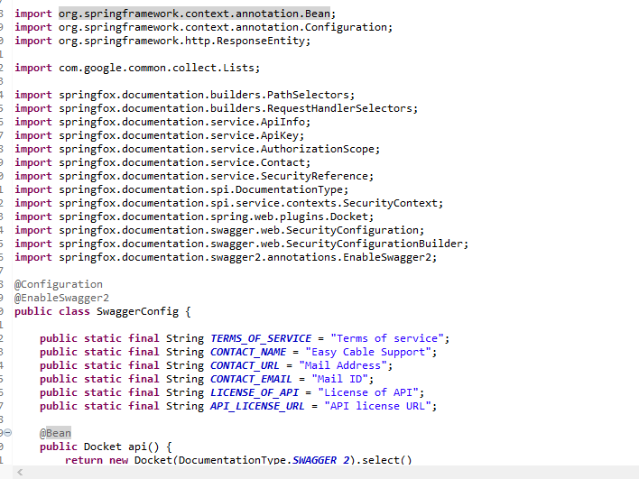

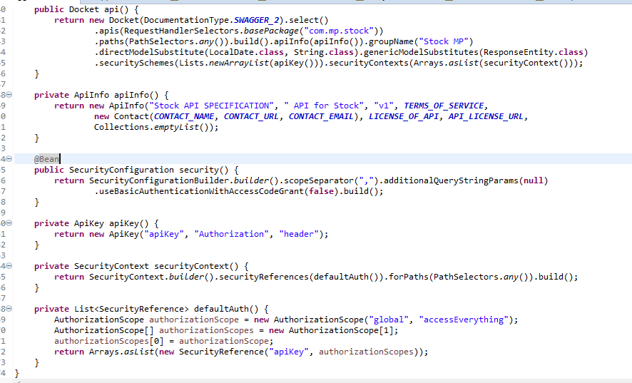

Note:

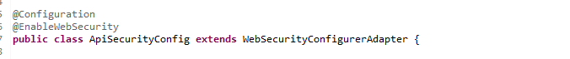

In this security class need to add the url for the grant permission.

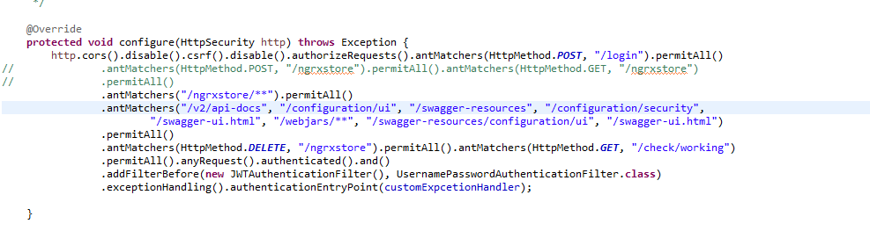

Issue I faced .

Full authentication error.

Added this below dependacny as well .

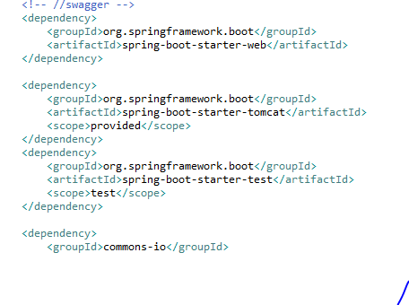

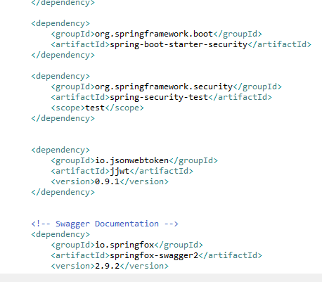

Application.properties.

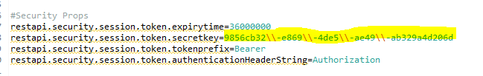

Added this secret key